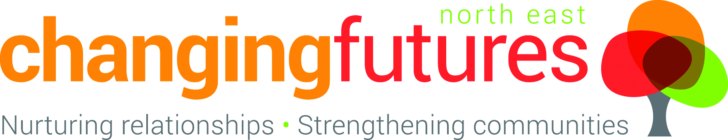
Job Opportunity
CYP IAPT Qualified Therapists (Systemic, LI HBT & HI CBT)
Salaries of £24,000 – £32,500 depending on post type and years qualified
Closing date: 4th October at 12 noon
Interview dates: Afternoon of Wednesday 13th October

Hours | Contract | Pension | Holidays | Working Hours
Full or part time, negotiable | Permanent subject to funding | Employer contribution 3% | 35 days including bank holidays | Usually between 8am and 8pm Monday to Friday.

We have an exciting opportunity for you to join a small Charity where you can make a big difference.

We are looking for CYP IAPT qualified therapists in multiple disciplines.

Changing Futures has been delivering under CYP IAPT for the last 18 months and is keen to continue to help children and families improve their mental health and live happy and fulfilled lives.

You will join an innovative and broad organisation that helps children to be safer, feel more secure and have the foundations to do well in life. The Charity supports individuals within a family, as well as key relationships in the family and outside of it.

Starting life as an estate-based youth club, Changing Futures now supports families, children and young people across Teesside through a range of projects including children’s therapy, couples therapy, mediation, parental group work, mentoring (for adults and children, focusing on understanding and alleviating the impact of trauma), befriending and fostering across Tees Valley. Because healthy organisational systems enable better help for families, we’ve also helped support practice and organisational development in children’s workforce agencies across Hartlepool.

Joining a team of 20 staff and 60+volunteers, you will have a chance to be part of a small family where you can make a big difference.

You can find out more about us by looking at our websites at www.changingfuturesne.co.uk www.changingfuturesfostering.co.uk and www.teesvalleymediation.co.uk.

You do need to have a CYP IAPT Postgraduate qualification to apply for this post and we regret that we can’t accept other qualifications.

For a job description please contact admin@changingfuturesne.co.uk stating which type of post you are interested in, or ring 01429891444.

